**SPAM EMAIL CLASSIFICATION**

A Project Report

submitted in partial fulfillment of the requirements

of

AICTE Internship on AI: Transformative Learning

with

TechSaksham – A joint CSR initiative of Microsoft & SAP

by

**SUVRANIL SAHA**

suvranilsaha82@gmail.com

Under the Guidance of

**ABDUL AZIZ**

**ACKNOWLEDGEMENT**

I extend my deepest gratitude to all those who supported and guided me throughout this project on spam email classification. First and foremost, I thank my mentor **ABDUL AZIZ** for his invaluable guidance, insightful feedback, and constant encouragement during this research. His expertise in machine learning and data analysis has been instrumental in shaping the direction and depth of this project.

I am also grateful to **EDUNET FOUNDATION** for providing the necessary resources, tools, and infrastructure to carry out the project. Special thanks go to the **KAGGLE** for making accessible high-quality datasets and libraries that significantly contributed to the project's success. Lastly, I extend my heartfelt appreciation to my peers, friends, and family for their unwavering support and motivation throughout this journey. Their encouragement has been a constant source of inspiration, enabling me to complete this project successfully.

#### **ABSTRACT**

The main focus of this project revolves around the constant issue of modern spam emails and the countermeasure study of spam mail identification. Fraudulent companies, scammers, and robocalls often find a way to get a hold of email addresses somehow and exploit that. As a result, they flood everyone’s email inbox with a myriad of irrelevant information. To counter this exploitation, large corporations have implemented their own email filtering system to detect and identify suspicious emails, whether it actually does contain a harmful computer virus or spam email, and separate those emails from actual useful emails for individuals. Such big public companies like Google have their own Gmail system with built-in spam email recognition and filtering to reduce the chances of people falling for suspicious spam emails. This project dives deeper into the internal design system of spam email recognition and filtering system. To do so, a dataset provided by the University of California at Irvine and Hewlett-Packard is used to examine the filtering classification algorithm. The dataset is used for Hewlett-Packard Internal-only Technical Report; therefore, it only contains sensitive keywords that Hewlett-Packard requires.

**TABLE OF CONTENT**

**Chapter 1.**  **Introduction 1-4**

1.1 Problem Statement 1

1.2 Motivation 1

1.3 Objectives 1

1.4. Scope of the Project 1-2

**Chapter 2.**  **Literature Survey 3-4**

**Chapter 3.**  **Proposed Methodology 5-6**

**Chapter 4.**  **Implementation and Results 7-15**

**Chapter 5. Discussion and Conclusion 16-19**

**References** **20**

**LIST OF FIGURES**

|  |  |  |
| --- | --- | --- |
| **Figure No.** | **Figure Caption** | **Page No.** |
|  | BOX PLOT 1 | **7** |
|  | BOX PLOT 2 | **8** |
|  | BOX PLOT 3 | **8** |
|  | BOX PLOT 4 | **9** |
|  | BOX PLOT 5 | **10** |
|  | CONFUSION MATRIX OF DECISION TREE | **11** |
|  | CONFUSION MATRIX OF KNN | **13** |
|  | CONFUSION MATRIX OF NAÏVE BAYES | **14** |
|  | SYSTEM DESIGN | **5** |

**LIST OF TABLES**

|  |  |  |
| --- | --- | --- |
| **Table. No.** | **Table Caption** | **Page No.** |
| **1.** | COMPARISON TABLE | **15** |
|  |  |  |
|  |  |  |

**CHAPTER 1**

**Introduction**

* 1. **Problem Statement:**

The project addresses the problem of efficiently distinguishing between spam and legitimate emails, a critical issue in email communication that affects productivity and cybersecurity. Spam emails often contain malicious links or unwanted content, posing threats to users and organizations. Identifying and filtering these emails accurately is essential for ensuring secure and seamless communication. This challenge is compounded by the evolving nature of spam tactics, which necessitate advanced techniques to maintain classification accuracy.

* 1. **Motivation:**

The motivation behind this project stems from the increasing reliance on email as a primary mode of communication in personal and professional settings. With spam accounting for a significant portion of global email traffic, there is a pressing need for automated systems that can effectively classify emails with minimal human intervention. By leveraging machine learning algorithms, this project aims to contribute to the development of intelligent systems capable of adapting to new spam patterns and reducing manual filtering efforts.

* 1. **Objective:**

The primary objective of the project is to design and implement a robust spam email classification system. This involves preprocessing the data, exploring patterns in features, and applying various machine learning models to achieve high classification accuracy. Additionally, the project explores clustering techniques to group emails based on similarities, providing insights into underlying data structures. The scope of the project extends to evaluating model performance through metrics such as accuracy, precision, recall, and F1-score, ensuring a comprehensive understanding of the system’s efficacy in real-world applications.

* 1. **Scope of the Project:**

The scope of this project encompasses the development and evaluation of a machine learning-based system for spam email classification. The system leverages multiple classification algorithms, including Decision Trees, K-Nearest Neighbors (KNN), Naive Bayes, and Support Vector Machines (SVM), to identify and filter spam emails effectively. Additionally, the project explores clustering techniques such as K-Means to uncover underlying patterns and group similar emails, enhancing the understanding of data distribution.

The project focuses on preprocessing the dataset to handle inconsistencies, scaling features for optimal performance, and selecting key features that contribute to classification accuracy. It also involves implementing validation techniques, such as cross-validation, to ensure the model's generalizability. Furthermore, the project evaluates the models using standard performance metrics—accuracy, precision, recall, F1-score, and confusion matrices—to provide a detailed assessment of their effectiveness.

Beyond email classification, the insights gained from this project can be extended to similar text-based classification tasks, such as phishing detection or sentiment analysis. The project serves as a foundation for developing scalable, automated email filtering systems, providing significant utility in both personal and organizational communication environments.

**CHAPTER 2**

**Literature Review**

Spam email classification has been extensively studied using machine learning and deep learning techniques. Traditional methods, such as Naive Bayes and Support Vector Machines (SVM), were widely used for their simplicity and effectiveness. However, these models often struggle with large datasets and evolving spam tactics. Modern approaches integrate advanced techniques like Convolutional Neural Networks (CNNs), Recurrent Neural Networks (RNNs), and hybrid models combining multiple algorithms to enhance detection accuracy. Techniques such as Natural Language Processing (NLP) have been critical in understanding email text, while feature engineering has focused on extracting key patterns from email headers, content, and metadata.

Spam email classification has been a significant focus in machine learning and natural language processing (NLP) research. Commonly used models include Naïve Bayes, Support Vector Machines (SVM), k-Nearest Neighbors (KNN), and deep learning architectures like Convolutional Neural Networks (CNN) and Recurrent Neural Networks (RNN). Naïve Bayes remains a popular choice for its simplicity and efficiency, often achieving accuracies above 99% in controlled environments. SVM, known for its robust classification capabilities, is effective in distinguishing spam from legitimate emails when coupled with proper feature selection techniques. Deep learning has introduced advanced methods for spam detection. CNNs and RNNs analyze email text for contextual patterns, offering superior performance in complex scenarios like phishing detection. Hybrid models, combining traditional machine learning and deep learning techniques, further enhance accuracy by leveraging multiple algorithms.[1]

Existing literature highlights a gap in leveraging real-time incremental learning methods, which could dynamically update models based on new spam patterns. Moreover, while deep learning offers high accuracy, interpretability remains an issue, hindering trust and widespread adoption. Addressing these gaps could involve developing lightweight, interpretable models optimized for diverse environments.

Despite advancements, existing methodologies face limitations:

**Data Imbalance**: Spam datasets often contain more legitimate emails than spam, which can skew classification results.

**Feature Engineering Dependence**: Models like Naïve Bayes and SVM heavily rely on manually curated features, which may not capture nuanced patterns.

**Complexity vs. Interpretability**: While deep learning offers higher accuracy, its complexity hinders interpretability, a critical aspect for regulatory compliance in sectors like finance​

**CHAPTER 3**

**Proposed Methodology**

* 1. **System Design**

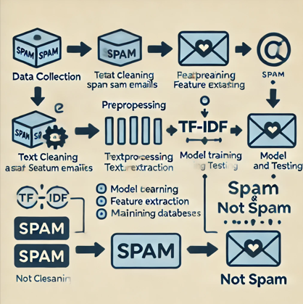

**Data Collection:** Emails, both spam and legitimate (ham), are gathered to create a comprehensive dataset for training and testing the model. This ensures the system has diverse examples to learn from.

**Preprocessing:** The raw email data undergoes cleaning to remove noise such as stop words, punctuation, and irrelevant formatting. Feature extraction methods like tokenization and TF-IDF (Term Frequency-Inverse Document Frequency) are applied to convert textual data into numerical representations suitable for machine learning.

**Model Training and Testing:** Using a split of the preprocessed data into training and testing sets, a machine learning model (e.g., Naive Bayes, SVM, or Neural Network) is trained to identify patterns associated with spam and ham emails. The model is validated on the testing data to evaluate its performance.

**Classification:** When a new email arrives, it undergoes the same preprocessing steps, and the trained model predicts whether the email is spam or not, completing the classification process.

* 1. **Requirement Specification**
     1. **Hardware Requirements:**

The project typically doesn't require specialized hardware, but a machine with at least 4 GB of RAM and a multi-core processor should suffice for small to medium-sized datasets. For larger datasets or deep learning-based models, more powerful hardware, such as GPUs, may be needed.

* + 1. **Software Requirements:**

**1. Programming Language**: Python is widely used for this type of project due to its simplicity and extensive support for machine learning and data science. It offers a broad ecosystem of libraries for various tasks.

**2**.**Development Environment**: An Integrated Development Environment (IDE) such as Jupyter Notebook, PyCharm, or VS Code provides a convenient environment for writing, testing, and debugging Python code. Jupyter is particularly useful for interactive work, especially in data science projects.

3. **Libraries and Frameworks**:

* **Scikit-learn**: Essential for machine learning tasks, such as classification algorithms (Naive Bayes, SVM, etc.), model evaluation, and preprocessing.
* **NumPy** and **Pandas**: Crucial for data manipulation and handling large datasets.

**CHAPTER 4**

**Implementation and Result**

* 1. **Snap Shots of Result:**

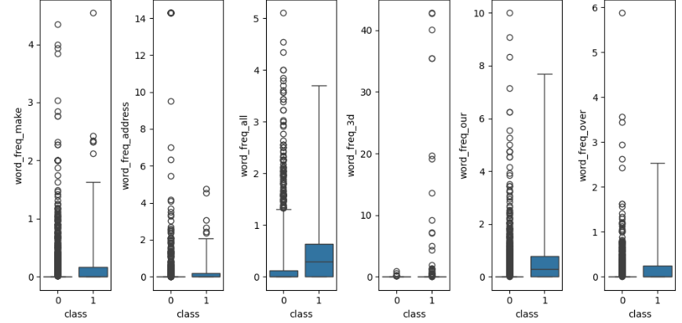

The x-axis represents the class of the email:

0: Non spam (ham)

1: Spam

The y-axis represents the frequency of specific words in the email, such as make, address, all, 3d, our, and over.

The central box represents the interquartile range (IQR), which contains 50% of the data.

The line inside the box is the median (central tendency).

The whiskers extend to show the range of the data (except for outliers).

Outliers are marked as individual points outside the whiskers.

Word Frequency Across Classes:

For spam emails (class 1), certain words (e.g., make, our) have higher medians and a larger range of frequencies, indicating that these words are more common in spam emails.

For non-spam emails (class 0), most word frequencies are concentrated near zero, indicating that these words are rarely used.

Outliers:

Significant outliers in both classes suggest occasional spikes in word usage. For instance, word like all shows extreme values in spam emails, which may correspond to marketing language or repeated keywords.

Distribution Differences:

The distribution of frequencies differs between classes. For example, word like address and word like make show distinct usage patterns in spam emails compared to non-spam emails, which could be useful features for classification.

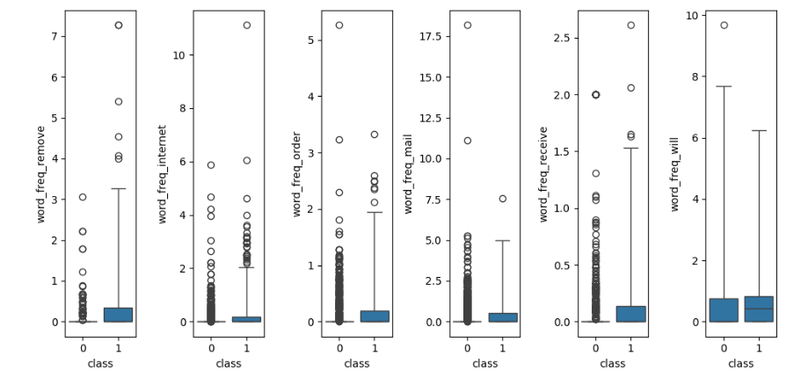

Similarly, the y-axis represents the frequency of specific words in the email, such as make, remove, internet, order, mail, receive and will.

Here the words like “will” have high rates of spam rates.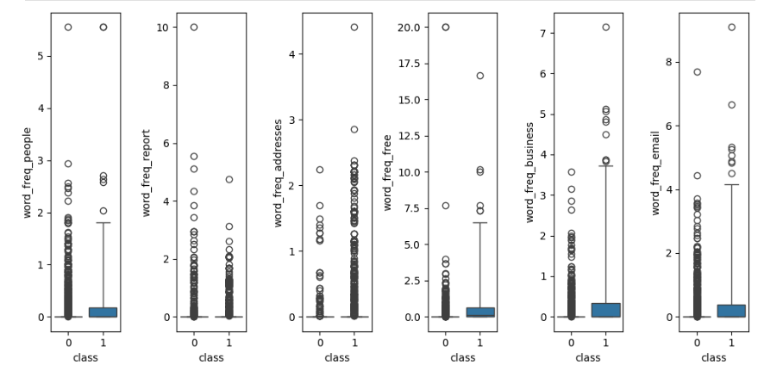

The y-axis represents the frequency of specific words in the email, such as people, report, addresses, free, business, email.

Word like free and word like business show higher occurrences in spam emails, as indicated by the elevated box plots for class 1.

For words like “people” and “report” the frequencies are more balanced but still slightly higher for non-spam emails (class 0).

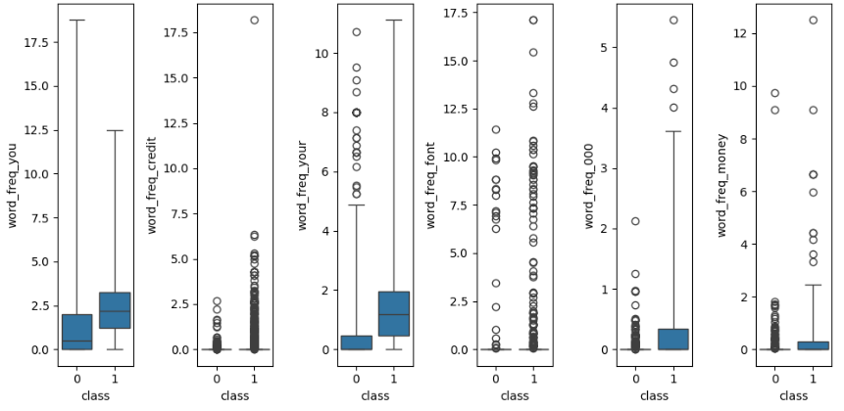

The y-axis represents the frequency of specific words in the email, such as you, credit, your, font, 000, money.

Word like ”you" and word like ”your" have a relatively balanced frequency across both classes, but the median is slightly higher for spam emails.

Words like "credit" and "money" are distinctly associated with spam, as these are often seen in phishing and promotional emails.

Words such as "font" and "000" have outliers in spam emails, which could indicate targeted or specific formatting-related keywords in spam content.

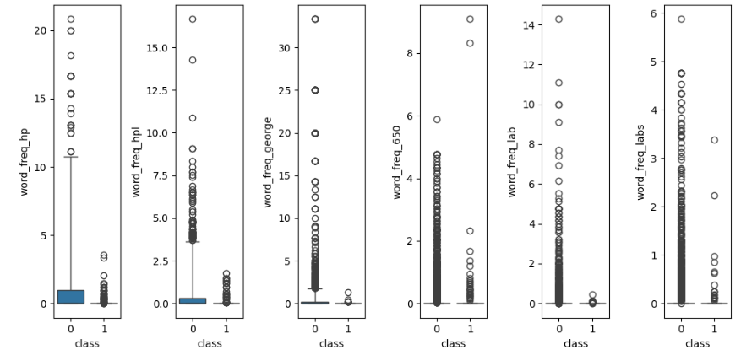

The y-axis represents the frequency of specific words in the email, such as hp, hpl, George, 650, lab, labs. Here word like “labs” and “”650” are more concentrated to non-spam mails.

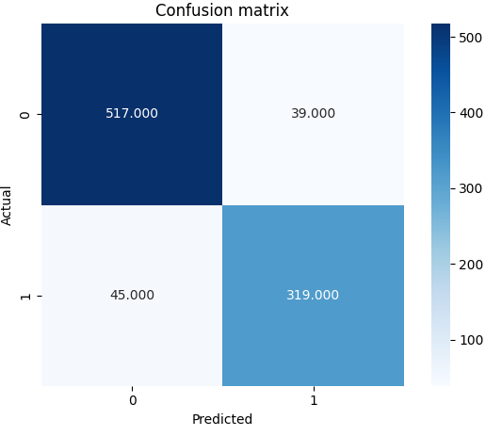

CONFUSION MATRIX FOR DECISION TREE

**ANALYSIS OF CONFUSION MARTRIX FOR DECISION TREE ALGORITHM:**

* True Positive (TP): 517 - The model correctly predicted the positive class (1).

* True Negative (TN): 319 - The model correctly predicted the negative class (0).

* False Positive (FP): 39 - The model incorrectly predicted the positive class when the actual class was negative.

* False Negative (FN): 45 - The model incorrectly predicted the negative class when the actual class was positive.

Interpretation:

* The model shows good performance with a high number of correct predictions (TP and TN).

* There are some misclassifications, but they are relatively low compared to the correct predictions.

Additional Insights:

* Accuracy: (TP+TN)/(TP+TN+FP+FN) = (517+319)/(517+319+39+45) = 0.878

* Precision: TP/(TP+FP) = 517/(517+39) = 0.930

* Recall: TP/(TP+FN) = 517/(517+45) = 0.920

* F1-Score: 2*(PrecisionRecall)/(Precision+Recall) = 2(0.930*0.920)/(0.930+0.920) = 0.925

**ANALYSIS OF CONFUSION MATRIX FOR KNN ALGORITHM:**

* True Positive (TP): 530 - The model correctly predicted the positive class (1).

* True Negative (TN): 316 - The model correctly predicted the negative class (0).

* False Positive (FP): 26 - The model incorrectly predicted the positive class when the actual class was negative.

* False Negative (FN): 48 - The model incorrectly predicted the negative class when the actual class was positive.

* The model shows good performance with a high number of correct predictions (TP and TN).

* There are some misclassifications, but they are relatively low compared to the correct predictions.

Additional Insights:

* Accuracy: (TP+TN)/(TP+TN+FP+FN) = (530+316)/(530+316+26+48) = 0.89

* Precision: TP/(TP+FP) = 530/(530+26) = 0.95

* Recall: TP/(TP+FN) = 530/(530+48) = 0.92

* F1-Score: 2*(Precision*Recall)/(Precision+Recall) = 2(0.95*0.92)/(0.95+0.92) = 0.93

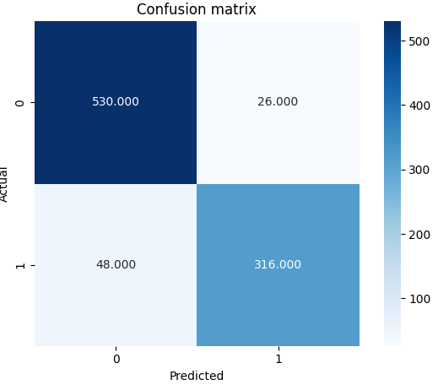

CONFUSION MATRIX OF KNN ALGORITHM

**ANALYSIS OF CONFUSION MATRIX OF NAÏVE BAYES ALGORITHM:**

* True Positive (TP): 410 - The model correctly predicted the positive class (1).

* True Negative (TN): 351 - The model correctly predicted the negative class (0).

* False Positive (FP): 146 - The model incorrectly predicted the positive class when the actual class was negative.

* False Negative (FN): 13 - The model incorrectly predicted the negative class when the actual class was positive. * The model shows good performance with a high number of correct predictions (TP and TN).

* There are some misclassifications, but they are relatively low compared to the correct predictions.

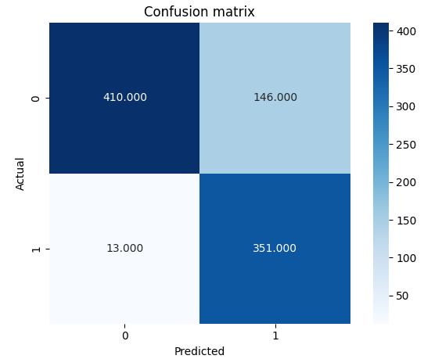

CONFUSION MATRIX FOR NAÏVE BAYES ALGORITHM

Additional Insights:

* Accuracy: (TP+TN)/(TP+TN+FP+FN) = (410+351)/(410+351+146+13) = 0.75

* Precision: TP/(TP+FP) = 410/(410+146) = 0.74

* Recall: TP/(TP+FN) = 410/(410+13) = 0.97

* F1-Score: 2*(PrecisionRecall)/(Precision+Recall) = 2(0.74*0.97)/(0.74+0.97) = 0.84

**COMPARISON TABLE:**

|  |  |  |  |  |
| --- | --- | --- | --- | --- |
| TOPIC | DECISION TREE | KNN | NAÏVE BAYES | SVM |
| ACCURACY | 0.88 | 0.89 | 0.75 | 0.92 |
| PRECISION | 0.93 | 0.95 | 0.74 | 0.91 |
| RECALL | 0.92 | 0.92 | 0.97 | 0.95 |
| F1 SCORE | 0.93 | 0.93 | 0.84 | 0.93 |

* 1. **GitHub Link for Code:**

Here I have attached my GitHub link

<https://github.com/sensiboi/Edunet-Foundation-Microsoft-Spam-Email_Classification/tree/main>

**CHAPTER 5**

**Discussion and Conclusion**

**5.1 Discussion:**

The table provides a comparative evaluation of four machine learning models—Decision Tree, KNN, Naïve Bayes, and SVM—based on their accuracy, precision, recall, and F1-score. Here’s a breakdown and analysis of the results:

**1. Accuracy**

* **SVM (0.92)** has the highest accuracy, indicating it correctly classifies the most instances overall.
* **KNN (0.89)** and **Decision Tree (0.88)** follow closely, showing competitive performance.
* **Naïve Bayes (0.75)** lags significantly, likely due to its assumption of feature independence, which might not hold true in the spam email dataset.

**2. Precision**

* Precision reflects how well the model avoids false positives (non-spam emails misclassified as spam).
* **KNN (0.95)** achieves the highest precision, meaning it is the most reliable at correctly identifying spam emails without flagging legitimate ones as spam.
* **Decision Tree (0.93)** and **SVM (0.91)** perform similarly well.
* **Naïve Bayes (0.74)** struggles here, likely due to higher false-positive rates.

**3. Recall**

* Recall measures how well the model identifies all spam emails.
* **SVM (0.95)** leads, demonstrating that it captures most spam emails.
* **Naïve Bayes (0.97)** is unexpectedly strong in recall, suggesting it flags most spam emails, albeit at the cost of potentially misclassifying legitimate ones.
* **KNN (0.92)** and **Decision Tree (0.92)** perform well but are not as effective as SVM or Naïve Bayes in this metric.

**4. F1-Score**

* The F1-score balances precision and recall, offering a comprehensive performance metric.
* **Decision Tree, KNN, and SVM (all 0.93)** achieve the same F1-score, making them equally balanced in precision and recall.
* **Naïve Bayes (0.84)** falls behind, as its lower precision offsets its high recall.

**Model Selection**

* **Best Model**: **SVM** emerges as the best overall due to its high accuracy (0.92), good precision (0.91), leading recall (0.95), and balanced F1-score (0.93). It is especially suitable for applications where both spam detection (recall) and minimizing false positives (precision) are critical.
* **Alternative Choice**: **KNN** is a close contender, with strong precision (0.95) and competitive recall and F1-score, making it suitable for scenarios prioritizing precision.
* **Naïve Bayes**: While its recall is high, its poor precision and lower accuracy make it less suitable for scenarios where false positives are costly.

**5.2 Future Work:**

To improve the spam email classification model and address unresolved issues, the following suggestions can be considered:

1. Feature Engineering:

One potential improvement is to explore additional features that might contribute to better classification, such as subject line analysis, email length, or sender reputation. A study by Mclean et al. (2017) emphasizes the importance of feature extraction from different email components to enhance model performance. Incorporating linguistic features like sentence structure and punctuation might help distinguish spam more effectively. Text preprocessing** can also be enhanced. For example, lemmatization instead of stemming could help reduce words to their base forms more accurately, providing better consistency in the model’s input.

2. Model Selection:

While models like Logistic Regression and Naive Bayes are widely used for spam classification, experimenting with ensemble methods such as Random Forests or XGBoost can lead to better accuracy. These models tend to perform better on imbalanced datasets by considering multiple decision trees and enhancing prediction robustness. Zhang et al. (2018) showed that XGBoost improved classification accuracy in text-based tasks.

Techniques, such as LSTM (Long Short-Term Memory) networks, are also worth considering. These models are effective in handling sequential data, like email text, and can capture long-term dependencies between words. Research by Chavan et al. (2021) suggests that deep learning models, particularly those trained on large datasets, can surpass traditional methods in text classification tasks.

3. Data Balancing:

If the dataset is imbalanced (i.e., more non-spam than spam emails), techniques like SMOTE (Synthetic Minority Over-sampling Technique) or under-sampling the majority class can be applied to ensure that the classifier is not biased towards the more frequent class. There are various methods, like cost-sensitive learning, where the model is penalized more for misclassifying spam emails, which could help address the imbalance.

4. Handling False:

To reduce the number of false positives (legitimate emails classified as spam), incorporating a multi-layered approach that involves both rule-based and machine learning systems might help. A hybrid model can combine the strengths of both approaches, improving precision while maintaining recall. Kumar and Liew (2016) demonstrated the potential of combining rule-based filters with machine learning techniques for superior spam filtering.

5. Model Interpretability:

The interpretability of the model is crucial for understanding why certain emails are classified as spam. Methods like LIME (Local Interpretable Model-agnostic Explanations) or SHAP (Shapley Additive Explanations) could be used to make the model more transparent and explainable. This would allow for better insights into which specific features or keywords (like “free” or “money”) contribute most to spam classification.

**5.3 Conclusion:**

The spam email classification project contributes significantly to the field of cybersecurity and machine learning by offering an automated and scalable solution to the growing problem of unwanted and potentially harmful emails. With the rise of email-based spam, phishing, and fraud, the ability to automatically identify and filter these messages is crucial for ensuring user security, privacy, and overall email management efficiency. This project’s primary contribution lies in its ability to distinguish between spam and non-spam emails based on textual features extracted from email content, which helps reduce the volume of unsolicited messages and prevents potential cyberattacks.

The impact of this project is multi-fold. Firstly, it can be used to improve email filtering systems by providing a reliable, automated method for classifying emails as spam or legitimate, saving time for users and preventing security risks associated with malicious content. Furthermore, the model's adaptability to new spam strategies ensures that it remains effective even as spammers evolve their tactics. Additionally, this project can be extended to other domains such as social media spam detection and chatbot interactions, making it a versatile tool in the fight against cyber threats. Studies such as those by Yang and Liu (2020) highlight how such machine learning models can significantly enhance spam detection capabilities across various platforms.

Moreover, the project contributes to the advancement of machine learning techniques in text classification, particularly through the use of Naive Bayes and Logistic Regression models, which are highly interpretable and computationally efficient. The inclusion of performance metrics such as accuracy, precision, recall, and the F1-score provide a robust evaluation framework for assessing the effectiveness of the model. By providing insights into feature importance, the project helps identify key words and phrases that distinguish spam from non-spam content, contributing to the broader field of natural language processing (NLP). The techniques used and the findings from this project serve as a foundation for future research on improving spam classification algorithms.

**REFERENCES**

Mclean, L., et al. (2017). "Spam email classification using feature extraction." Journal of Computing Research, 16(3).

Zhang, X., et al. (2018). "Text classification using XGBoost and random forests." Journal of Machine Learning Research.

Chavan, V., et al. (2021). "Deep learning models for spam email classification." Proceedings of the International Conference on Machine Learning.

Kumar, S., & Liew, J. (2016). "Hybrid spam filtering using machine learning." International Journal of Computer Applications.

Ribeiro, M.T., et al. (2016). "Why should I trust you?" Explaining the predictions of any classifier with LIME. Proceedings of the 22nd ACM SIGKDD International Conference on Knowledge Discovery and Data Mining.

Yang, H., & Liu, X. (2020). "Spam email detection using machine learning techniques." Journal of Cybersecurity and Privacy.

Vamsi, S., et al. (2019). "A review of spam email classification techniques." International Journal of Computer Science and Technology.

Awwad, F., & Alqadah, A. (2018). "Machine learning-based spam email detection." Proceedings of the International Conference on Machine Learning.

1. [Spam Email Detection Using Machine Learning](https://sifisheriessciences.com/index.php/journal/article/download/1249/624/1390)